Assignment 3 Intro to comp sci

Global Warming over the years

By Jeremy Francey

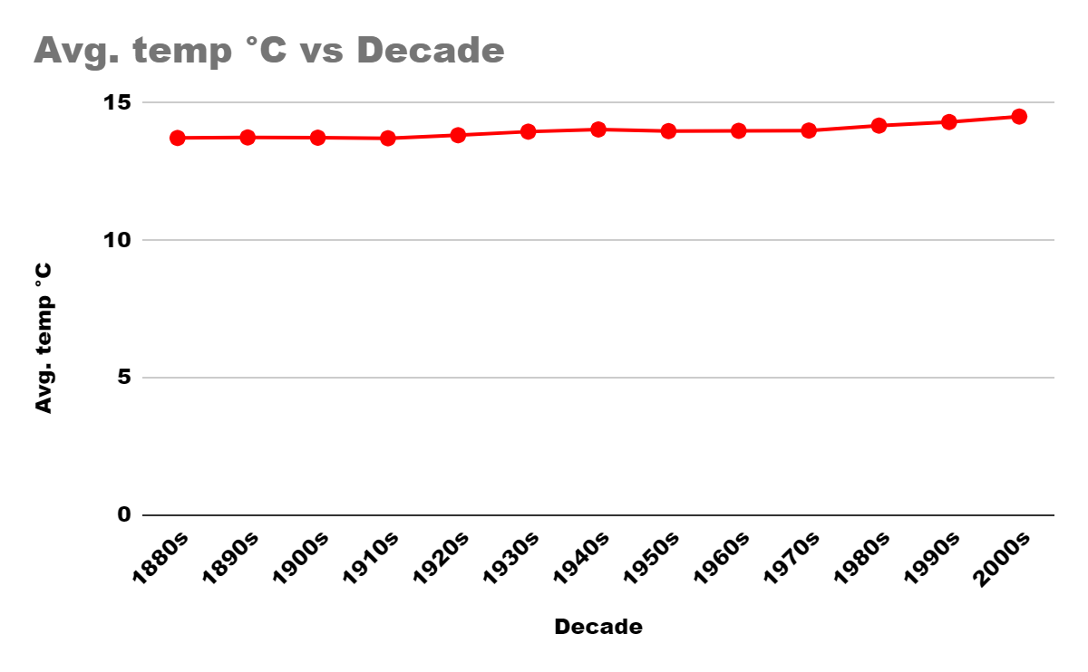

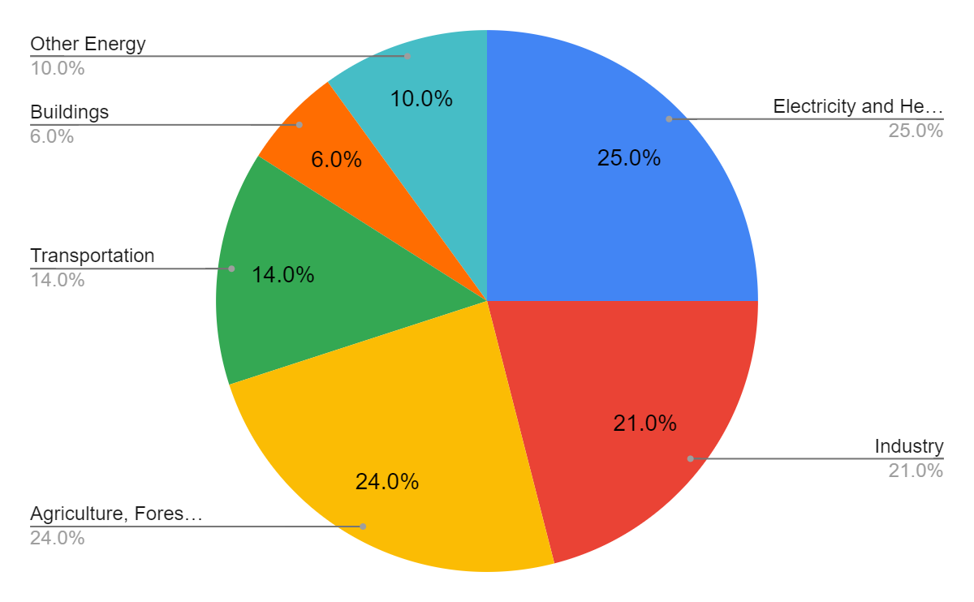

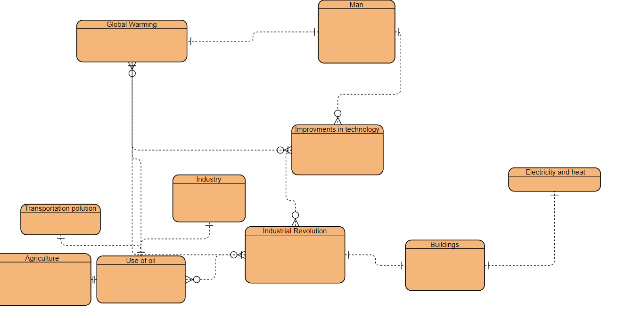

As you can clearly see by the data that global temperature is a real phenomenon, the earth's temperature is increasing year after year. We only have a few years left before the point of no returns. The data I have shows the issue and the main causes of global warming. Agriculture, Industry and electricity and heating being the major contributors to greenhouse gas emissions that keeps the hot air in the earth’s atmosphere causing it to slowly increase year by year. We need to reduce our greenhouse gas emissions as soon as possible to stop the steady incline of the earth’s temperature which will lead to our inevitable death.

Sources:

<https://www.epa.gov/ghgemissions/global-greenhouse-gas-emissions-data>

<https://climate.nasa.gov/vital-signs/ice-sheets/>

<https://climate.nasa.gov/>